594. Longest Harmonious Subsequence

We define a harmonious array is an array where the difference between its maximum value and its minimum value is **exactly** 1.

Now, given an integer array, you need to find the length of its longest harmonious subsequence among all its possible [subsequences](https://en.wikipedia.org/wiki/Subsequence).

Example 1:

Input: [1,3,2,2,5,2,3,7]

Output: 5

Explanation: The longest harmonious subsequence is [3,2,2,2,3].

Solution:

def findLHS(self, A):

count = collections.Counter(A)

ans = 0

for x in count:

if x+1 in count:

ans = max(ans, count[x] + count[x+1])

return ans

*alternatively:*

import collections

def findLHS(nums):

count = collections.Counter(nums)

print count

return max([count[x] + count[x+1] for x in count if count[x+1]] or [0])

593. Valid Square

Given the coordinates of four points in 2D space, return whether the four points could construct a square.

The coordinate (x,y) of a point is represented by an integer array with two integers.

**Example:**

**Input:** p1 = [0,0], p2 = [1,1], p3 = [1,0], p4 = [0,1] **Output:** True

Note:

1. All the input integers are in the range [-10000, 10000].
2. A valid square has four equal sides with positive length and four equal angles (90-degree angles).
3. Input points have no order.

592. Fraction Addition and Subtraction

Given a string representing an expression of fraction addition and subtraction, you need to return the calculation result in string format. The final result should be [irreducible fraction](https://en.wikipedia.org/wiki/Irreducible_fraction). If your final result is an integer, say 2, you need to change it to the format of fraction that has denominator 1. So in this case, 2 should be converted to 2/1.

**Example 1:**

**Input:**"-1/2+1/2" **Output:** "0/1"

**Example 2:**

**Input:**"-1/2+1/2+1/3" **Output:** "1/3"

**Example 3:**

**Input:**"1/3-1/2" **Output:** "-1/6"

**Example 4:**

**Input:**"5/3+1/3" **Output:** "2/1"

**Note:**

1. The input string only contains '0' to '9', '/', '+' and '-'. So does the output.
2. Each fraction (input and output) has format ±numerator/denominator. If the first input fraction or the output is positive, then '+' will be omitted.
3. The input only contains valid **irreducible fractions**, where the **numerator** and **denominator** of each fraction will always be in the range [1,10]. If the denominator is 1, it means this fraction is actually an integer in a fraction format defined above.
4. The number of given fractions will be in the range [1,10].
5. The numerator and denominator of the **final result** are guaranteed to be valid and in the range of 32-bit int.

588. Design In-Memory File System My SubmissionsBack To Contest

Design an in-memory file system to simulate the following functions:

ls: Given a path in string format. If it is a file path, return a list that only contains this file's name. If it is a directory path, return the list of file and directory names in this directory. Your output (file and directory names together) should in lexicographic order.

mkdir: Given a directory path that does not exist, you should make a new directory according to the path. If the middle directories in the path don't exist either, you should create them as well. This function has void return type.

addContentToFile: Given a file path and file content in string format. If the file doesn't exist, you need to create that file containing given content. If the file already exists, you need to append given content to original content. This function has void return type.

readContentFromFile: Given a file path, return its content in string format.

Example:

Input:

["FileSystem","ls","mkdir","addContentToFile","ls","readContentFromFile"]

[[],["/"],["/a/b/c"],["/a/b/c/d","hello"],["/"],["/a/b/c/d"]]

Output:

[null,[],null,null,["a"],"hello"]

Explanation:

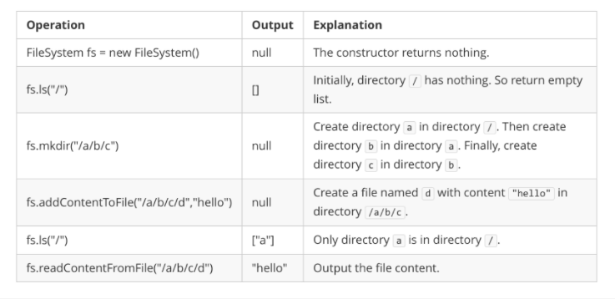

Note:

You can assume all file or directory paths are absolute paths which begin with / and do not end with / except that the path is just "/".

You can assume that all operations will be passed valid parameters and users will not attempt to retrieve file content or list a directory or file that does not exist.

You can assume that all directory names and file names only contain lower-case letters, and same names won't exist in the same directory.